INTRODUCTION

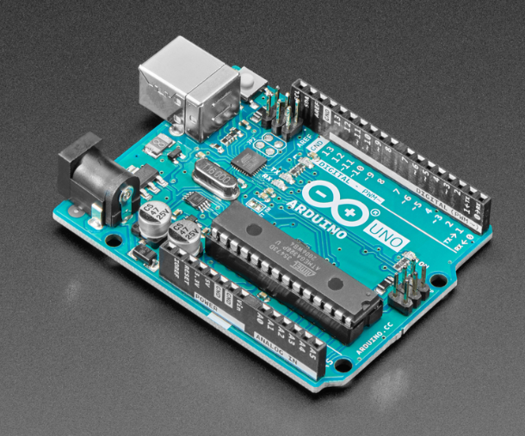

**Vision of Bootcamp:**

The **Arduino Bootcamp** is an immersive, hands-on learning experience designed to introduce participants to the world of embedded systems and electronics using the Arduino platform. This bootcamp is ideal for students and enthusiasts who want to learn microcontroller programming, sensor interfacing, and real-world project development in a simple and practical way.

**What is Included in the Arduino Bootcamp?**

* Comprehensive Course Material
* Practical Experience with Arduino IDE and Tools
* Hardware Kits (Arduino board, sensors, actuators)
* Interfacing sensors
* Hands-on Mini and Major Projects
* Expert Guidance and Mentorship

**What to Expect During the Arduino Bootcamp?**

**Foundational Learning:**  
Learn Arduino basics, embedded system concepts, digital and analog signals, and Arduino programming. Set up the Arduino IDE and upload programs to the board.

**Peripheral Interfacing:**  
Work with LEDs, buttons, buzzers, relays, and sensors like temperature, IR, ultrasonic, and LDR. Explore PWM for motor control and LED dimming, along with Serial, I2C, and SPI communication.

**Project-Based Learning:**  
Develop real-time projects such as smart lighting, obstacle avoidance, and sensor-based automation while applying concepts to real-world problems.

**Who Should Attend?**

* **Beginners:** Perfect for those new to electronics, embedded systems, or programming
* **Intermediate Learners:** Students with basic electronics or Arduino knowledge can strengthen their practical skills
* **Professionals:** Engineers and developers looking to prototype ideas quickly or enter IoT and automation domains
* **Hobbyists & Makers:** Ideal for DIY enthusiasts interested in building innovative electronic projects

**Prerequisites**

* Basic problem-solving skills
* Basic understanding of programming (Arduino or C is a plus)
* A laptop with Arduino IDE installed

INSTALLISATION

**Arduino ide Installation Guide**

**1. Go to the Website & Click "Download":**

https://www.arduino.cc/en/software/

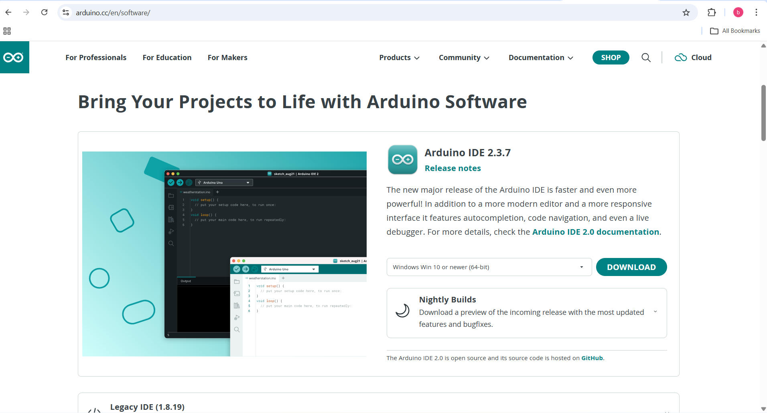

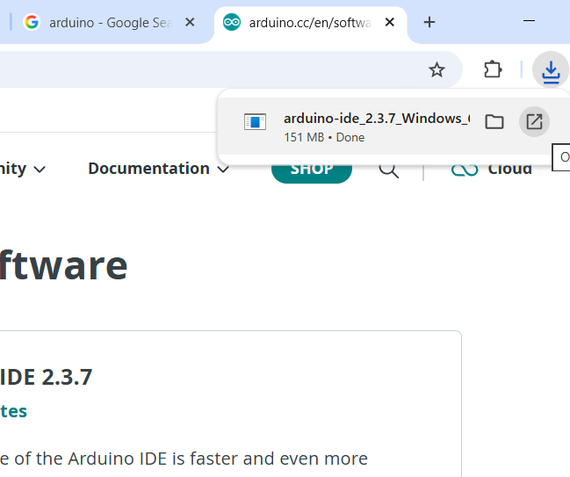**2.INSTALL IT**

**8. Launch ArduinoIDE:**

After installation, go to your desktop and open ArduinoIDE to start your project.

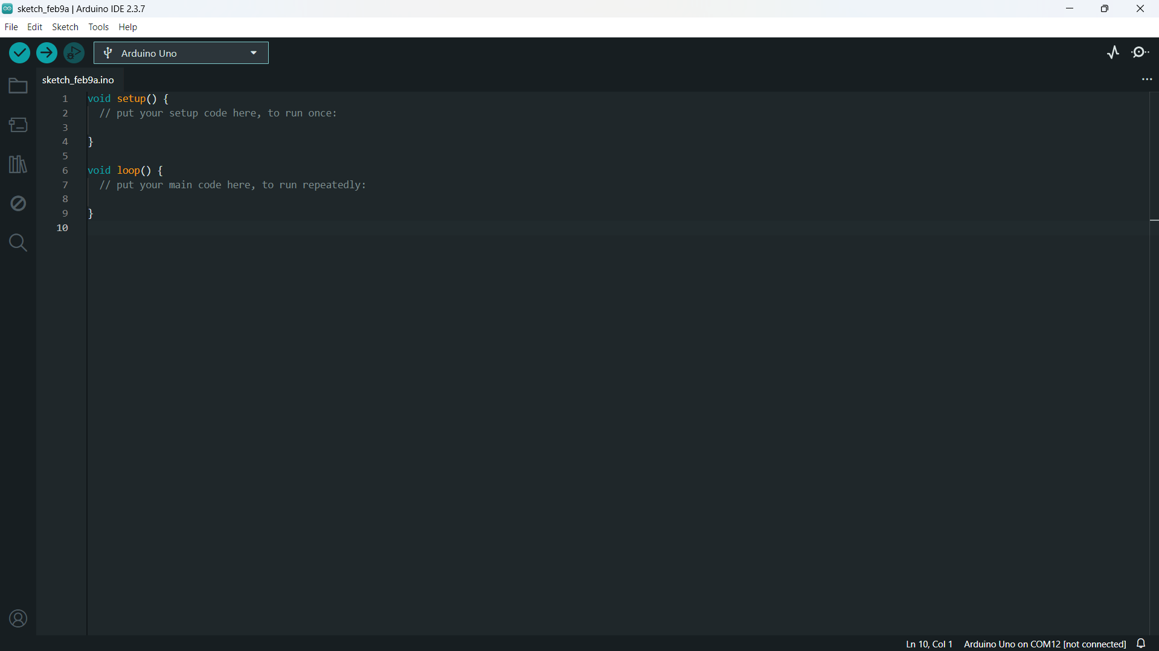

used for **main program execution**.

is used to **initialize** the Arduino.

Getting started

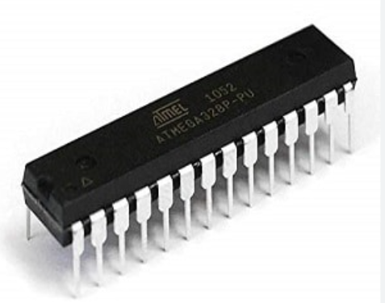ATmega328P

https://ww1.microchip.com/downloads/en/DeviceDoc/Atmel-7810-Automotive-Microcontrollers-ATmega328P_Datasheet.pdf

The **ATmega328P** is an 8-bit microcontroller developed by **Microchip Technology** (formerly Atmel). It is based on the **AVR RISC architecture** and is best known as the core microcontroller used in popular Arduino boards such as the **Arduino Uno**.

**Key Features**

**Microcontroller Family:**  
The ATmega328P belongs to the AVR microcontroller family and is widely used in education, prototyping, and small-scale embedded system applications due to its simplicity, reliability, and ease of use.

**AVR Core:**  
Based on an 8-bit AVR RISC architecture, it offers efficient instruction execution with most instructions completing in a single clock cycle, making it suitable for basic real-time tasks.

**Operating Frequency:**  
Runs up to **20 MHz**, providing sufficient performance for control systems, sensor interfacing, and basic automation projects.

**Peripherals:**  
Integrated peripherals include GPIOs, timers/counters, PWM channels, 10-bit ADC, USART, SPI, and I2C (TWI), enabling easy interfacing with sensors, displays, and communication modules.

**Power Efficiency:**  
Designed for low-power operation with multiple sleep modes, making it suitable for battery-powered and portable applications.

**Memory:**  
Features **32 KB Flash**, **2 KB SRAM**, and **1 KB EEPROM**, which is adequate for small to medium-complexity embedded programs.

**Development Tools**

**Arduino IDE:**  
A beginner-friendly development environment that simplifies coding, compiling, and uploading programs to the ATmega328P.

**AVR-GCC Toolchain:**  
Supports embedded C programming with direct register-level access for advanced users.

**Bootloader Support:**  
Allows easy program uploading via USB without the need for external programmers.

**Use Cases**

* Educational and academic projects
* DIY electronics and hobbyist applications
* Sensor-based systems and home automation
* Basic robotics and control systems
* Rapid prototyping of embedded ideas

**Popular Boards Using ATmega328P**

* Arduino Uno
* Arduino Nano
* Arduino Pro Mini

**Why ATmega328P is Popular?**

The **ATmega328P** is highly popular due to its simplicity, strong community support, extensive libraries, and ease of learning. While it may not match the performance or real-time capabilities of 32-bit microcontrollers like STM32, it remains an excellent choice for beginners and rapid prototyping where ease of use and reliability are more important than high processing power.

**ARDUINO UNO**

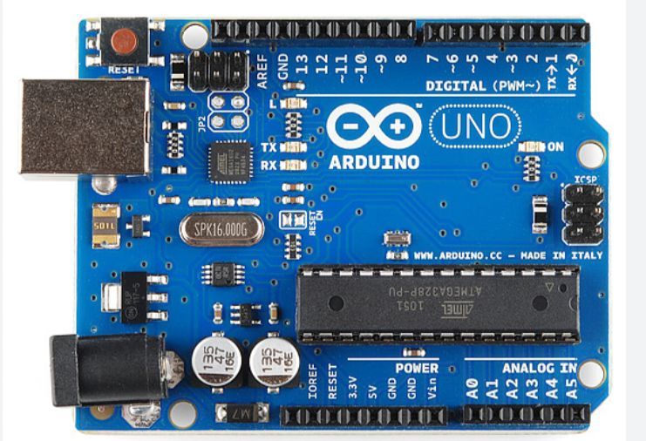

<https://docs.arduino.cc/resources/datasheets/A000066-datasheet.pdf>

The **Arduino Uno** is a widely used development board designed around the **ATmega328P microcontroller**, developed by **Microchip Technology**. It provides a simple, flexible, and beginner-friendly platform for learning embedded systems, rapid prototyping, and building real-world electronic projects.

**Key Features**

**Microcontroller:**  
Based on the **ATmega328P MCU** featuring:

* 8-bit AVR RISC architecture
* Clock frequency of **16 MHz**
* Flash memory: **32 KB**
* SRAM: **2 KB**
* EEPROM: **1 KB**

**Ease of Use:**  
Designed for simplicity, the Arduino Uno allows users to start programming without deep knowledge of hardware registers or complex toolchains.

**Arduino Shield Compatibility:**  
The board supports standard Arduino shield headers, enabling easy expansion using motor drivers, sensors, communication modules, displays, and IoT shields.

**USB Interface:**  
Built-in USB-to-Serial converter allows easy programming and serial communication directly from a PC.

**Integrated Programmer:**  
Supports bootloader-based programming, eliminating the need for external programmers.

**Connectivity**

* **USB Type-B port** for programming and power
* Communication interfaces:
  + USART (Serial)
  + I2C (TWI)
  + SPI
* Digital and analog I/O pins for sensor and actuator interfacing

**Power Supply**

* Powered via USB (5V) or external **7–12V DC** supply
* On-board voltage regulators provide stable **5V and 3.3V** outputs
* Suitable for standalone and portable applications

**Flexible Prototyping**

The Arduino Uno provides easy access to all GPIO pins, including:

* **14 Digital I/O pins** (6 PWM-enabled)
* **6 Analog input pins (10-bit ADC)**
* Support for LEDs, motors, relays, sensors, and displays

This makes it ideal for fast prototyping and experimentation.

**Development Tools**

**Arduino IDE:**  
A simple, cross-platform development environment for writing, compiling, and uploading programs.

**Extensive Libraries:**  
Large collection of built-in and community-supported libraries for sensors, communication modules, and peripherals.

**Serial Monitor & Plotter:**  
Useful tools for debugging and real-time data visualization.

**Applications**

**Educational Projects:**  
Widely used in schools and colleges for teaching embedded systems and electronics.

**DIY & Hobbyist Projects:**  
Ideal for home automation, smart gadgets, and personal electronics projects.

**Basic Robotics:**  
Used in line followers, obstacle avoidance robots, and motor control applications.

**IoT Prototyping:**  
With additional Wi-Fi or Bluetooth modules, Arduino Uno is suitable for entry-level IoT projects.

**Pinout and Peripherals**

**Digital I/O Pins:**  
Used for LEDs, switches, relays, and digital sensors.

**Analog Inputs:**  
10-bit ADC for reading analog sensor data.

**Timers and PWM:**  
Support motor control, LED dimming, and timing applications.

**Communication Interfaces:**

* Serial (UART)
* I2C
* SPI

**Why Choose Arduino Uno?**

**Beginner-Friendly:**  
Easy to learn with minimal setup and a gentle learning curve.

**Rapid Prototyping:**  
Perfect for quickly testing ideas and building functional prototypes.

**Massive Community Support:**  
Large global community, tutorials, libraries, and documentation.

**Reliable & Proven:**  
Used worldwide in education, research, and hobbyist projects.

**ARDUINO UNO Pin-Out**

https://www.circuito.io/blog/arduino-uno-pinout/

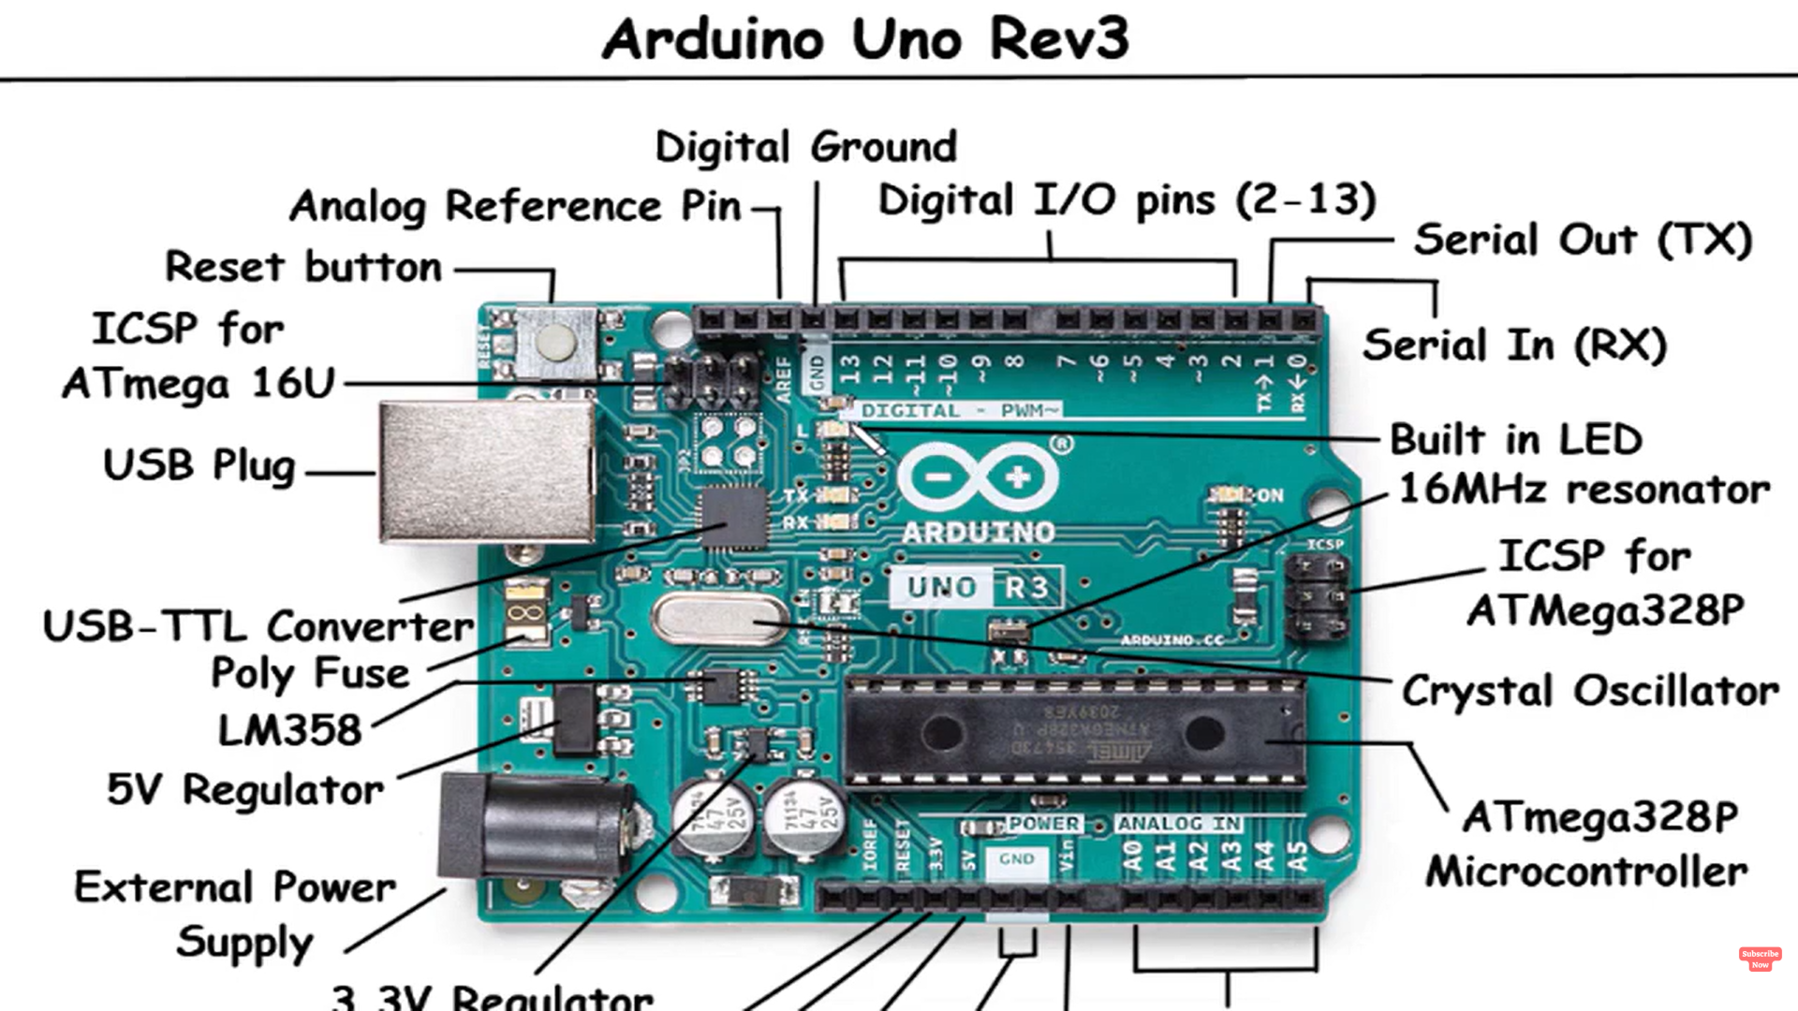

**GPIO Pins:**

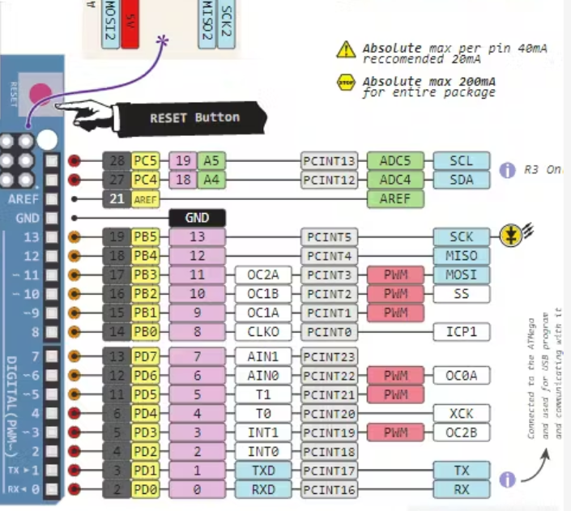

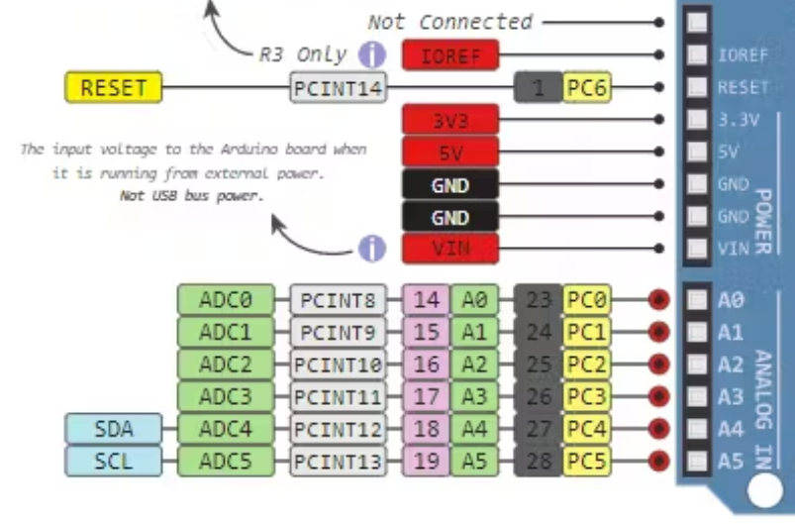

**Basic**

**Experiment 1(a)**

**Control of In-Built LED Using Arduino**

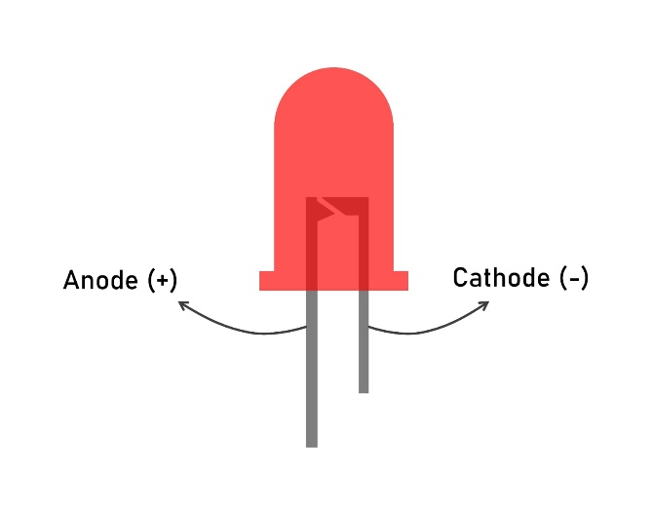

**Description**

Arduino UNO consists of an in-built LED internally connected to digital pin 13.  
This LED can be controlled directly through software without using any external components.

**Working**

The in-built LED is controlled by applying digital logic levels to pin 13.

* Logic HIGH at pin 13 turns the LED ON
* Logic LOW at pin 13 turns the LED OFF

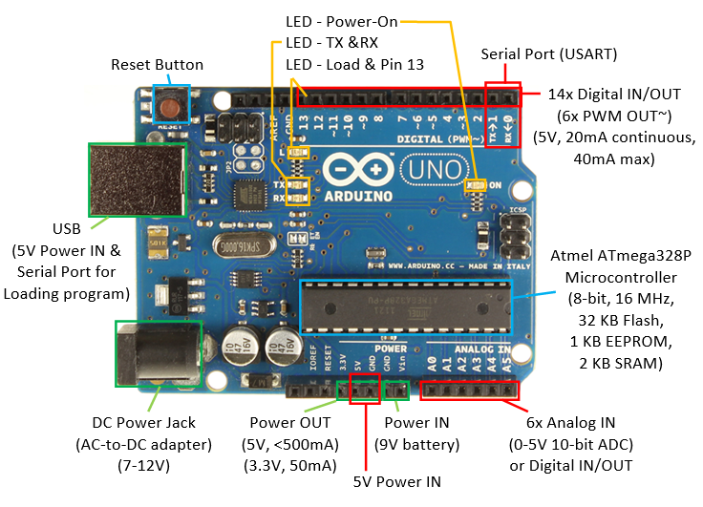

**Program**

#define led 13

void setup() {

pinMode(led, OUTPUT);

}

void loop() {

digitalWrite(led, HIGH);

delay(1000);

digitalWrite(led, LOW);

delay(1000);

}

**Observation**

The in-built LED glows for one second and turns OFF for one second repeatedly.

**Experiment 1(b)**

**Control of LEDs and Buzzer Using Push Buttons**

**Introduction**

This experiment demonstrates digital input and output interfacing using an Arduino microcontroller.

**Components Used**

* Arduino UNO
* Push buttons – 3
* LEDs – 3
* Buzzer
* **Resistors – 220 Ω / 330 Ω (for LEDs)**
* Breadboard
* Jumper wires

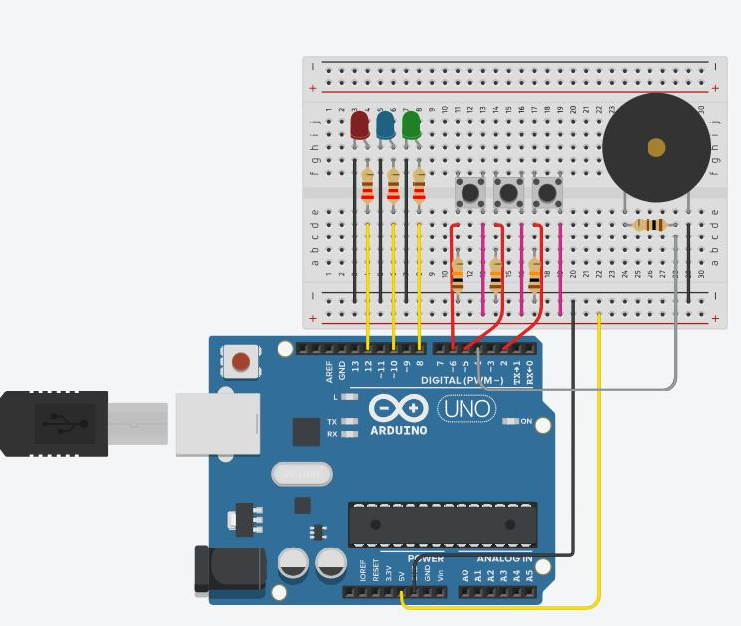

**Program Description**

Input: Buttons

Output: Led’s, Buzzer

**Arduino Program**

int led1 = 12;

int led2 = 10;

int led3 = 8;

int sw1 = 6;

int sw2 = 5;

int sw3 = 2;

int buzzer = 4;

void setup() {

pinMode(led1, OUTPUT);

pinMode(led2, OUTPUT);

pinMode(led3, OUTPUT);

pinMode(sw1, INPUT);

pinMode(sw2, INPUT);

pinMode(sw3, INPUT);

pinMode(buzzer, OUTPUT);

}

void loop() {

int s1 = digitalRead(sw1);

int s2 = digitalRead(sw2);

int s3 = digitalRead(sw3);

digitalWrite(led1, s1);

digitalWrite(led2, s2);

digitalWrite(led3, s3);

if (s1 == HIGH || s2 == HIGH || s3 == HIGH)

digitalWrite(buzzer, HIGH);

else

digitalWrite(buzzer, LOW);

}

**Observation**

* LEDs respond directly to their respective push button inputs.
* The buzzer is activated when any switch input is pressed.
* All outputs are disabled when all inputs are unpressed.

**Experiment 2:**

**IR sensor and servo motor**

**IR sensor**

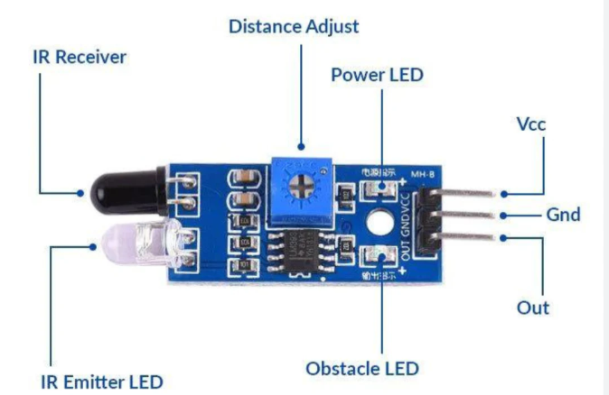

**Pinout:**

* Pin 1 **VCC** (+5V)
* Pin 2 **DigitalOut** (Connected to PA6 [D12])
* Pin 3 **GND** (Ground)

**Circuit Diagram**

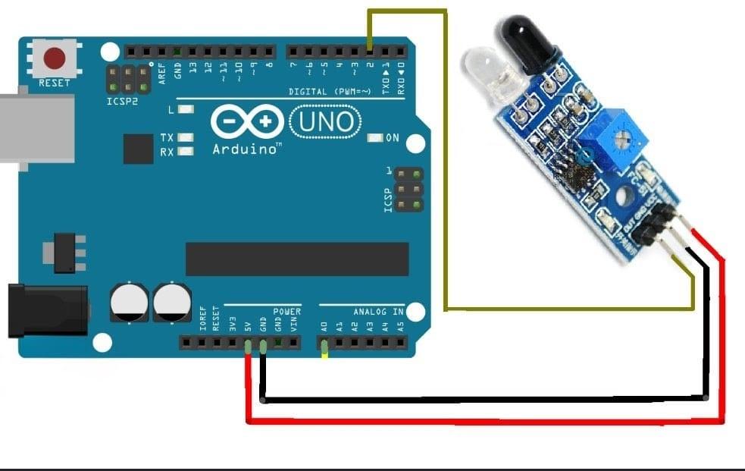

**THEORY:**

An **IR (Infrared) sensor** is an electronic device used to detect objects and obstacles using infrared light. It consists of an **IR transmitter (IR LED)** and an **IR receiver (photodiode or phototransistor)**.

The transmitter emits infrared rays, and when these rays hit an object, they are reflected back and detected by the receiver. Based on the reflected signal, the sensor determines whether an object is present or not.

The output of the IR sensor can be **digital (HIGH/LOW)** or **analog**, depending on the module. It is commonly used in obstacle detection, line-following robots, automatic doors, and security systems

**CODE:**

**int irPin = 2;**

**int led = 13;**

**void setup() {**

**pinMode(irPin, INPUT);**

**pinMode(led, OUTPUT);**

**}**

**void loop() {**

**int irValue = digitalRead(irPin);**

**if (irValue == HIGH) { // object detected**

**digitalWrite(led, HIGH);**

**} else {**

**digitalWrite(led, LOW);**

**}**

**}**

**Servo motor:**

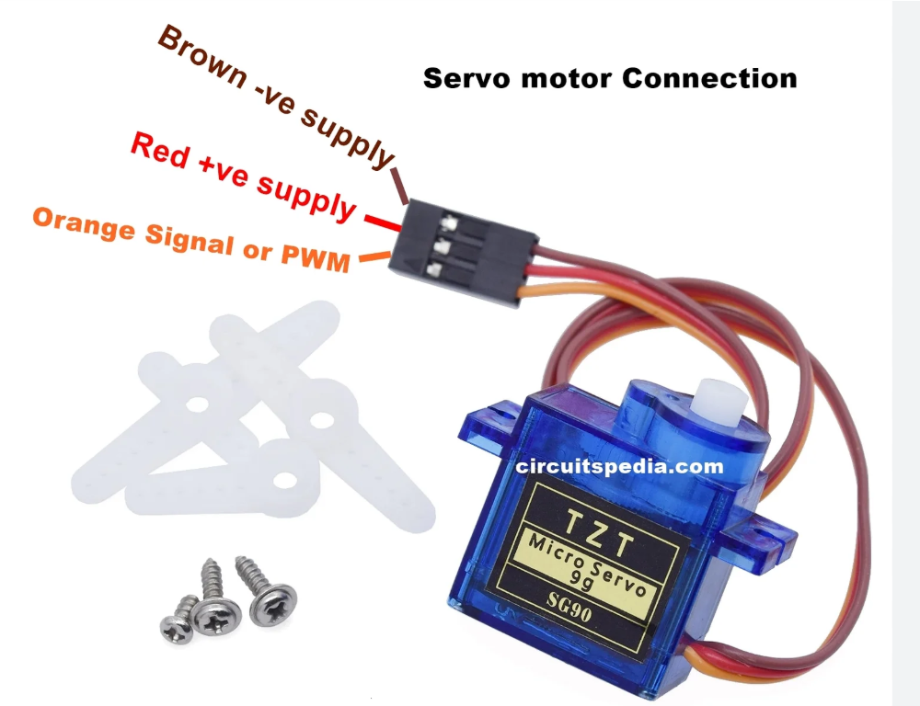

**Specifications:**

**Angle: 0 to 180 degrees**

**Pinout:**

* **Black/Brown ground wire**
* **Red power wire (around 5V)**
* **Yellow or White PWM wire**

**Circuit Diagram**

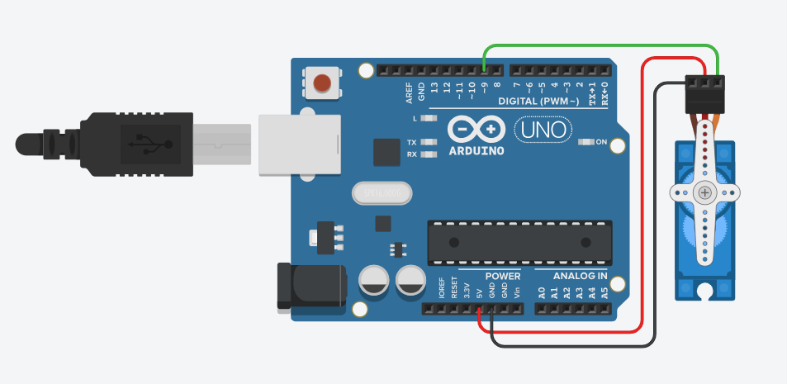

**THEORY**

A servo motor is a position-control device used to rotate an object to a specific angle. It works using a control signal called Pulse Width Modulation (PWM). The motor moves to the angle based on the width of the pulse it receives.

A servo motor has three main parts: a DC motor, a control circuit, and a feedback sensor (potentiometer). The control circuit compares the input signal with the current position of the motor. If there is a difference, the motor rotates until it reaches the required position.

**code**

#include <Servo.h>

Servo myServo;

void setup(){

myServo.attach(9); // Servo connected to PWM pin 9

}

void loop(){

myServo.write(0); // 0° position

delay(2000);

myServo.write(90); // 90° position

delay(2000);

myServo.write(180); // 180° position

delay(2000);

}

**IR sensor and servo motor**

**“This project uses a single IR sensor to detect an object and control a servo motor, which rotates automatically when an object is detected.”**

**Circuit Diagram**

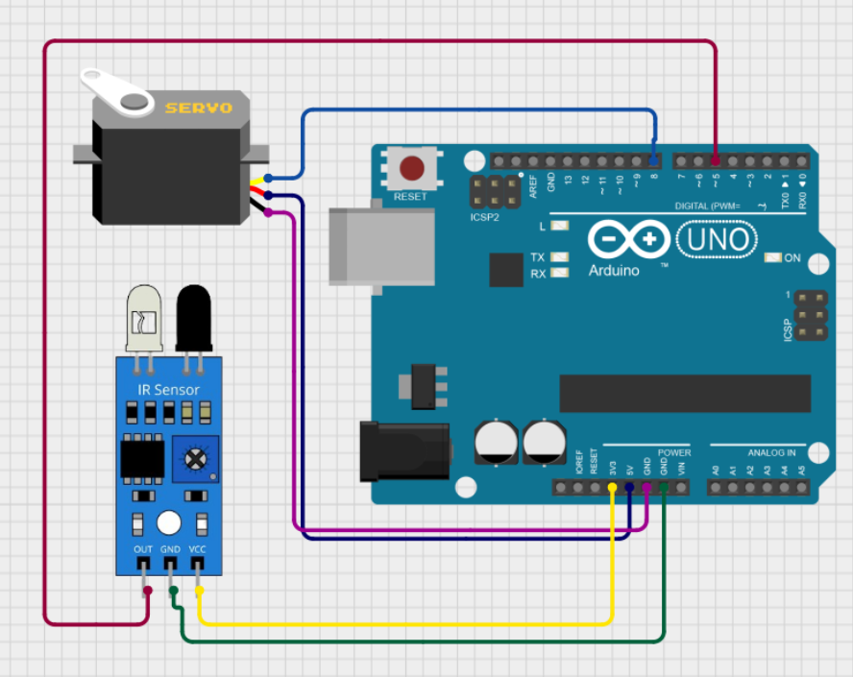

**Code:**

#include <Servo.h>

Servo myServo;

int irPin = 2; // IR sensor output pin

void setup()

{

pinMode(irPin, INPUT); // IR sensor as input

myServo.attach(9); // Servo connected to pin 9

Serial.begin(9600); // Serial monitor

}

void loop()

{

int irValue = digitalRead(irPin); // Read IR sensor

if (irValue == LOW) // Object detected

{

myServo.write(90); // Rotate servo to 90°

Serial.println("Object Detected - Servo ON");

}

else

{

myServo.write(0); // Rotate servo to 0°

Serial.println("No Object - Servo OFF");

}

delay(200); // Small delay

}

**ultrasonic sensor and smoke sensor :**

**ultrasonic sensor :**

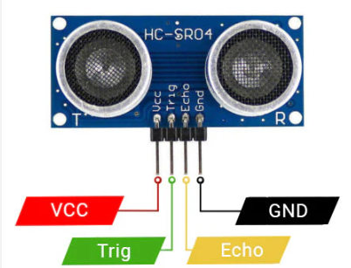

**Theory**

An ultrasonic sensor is a distance-measuring device that works using high-frequency sound waves. It transmits ultrasonic waves (usually 40 kHz) and receives the reflected echo from an object. By measuring the time taken for the echo to return, the distance of the object can be calculated.

The sensor has two main parts: a transmitter (Trig) and a receiver (Echo). The Arduino sends a short trigger pulse to the sensor, which emits ultrasonic waves. When these waves hit an object, they reflect back and are detected by the Echo pin.

Pin Mode:

| **Pin** | **Function** | **Arduino Pin Mode** |
| --- | --- | --- |
| VCC | Power supply | 5V |
| Trig | Sends ultrasonic pulse | OUTPUT(9) |
| Echo | Receives reflected pulse | INPUT(10) |
| GND | Ground | GND |

**Circuit Diagram:**

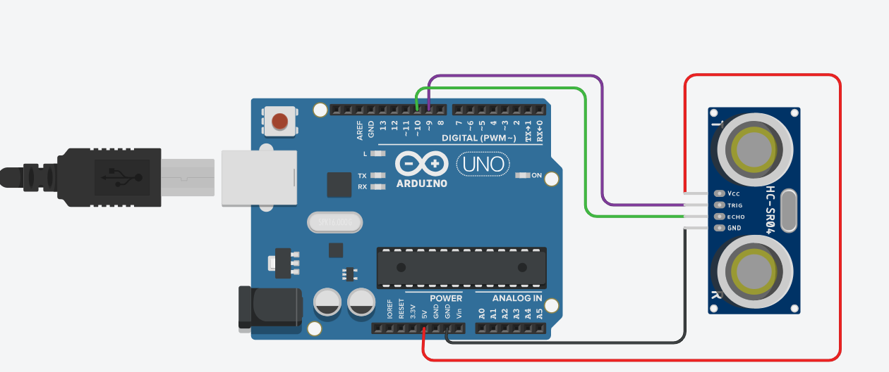

**Code:**

int trigPin = 9; // Trigger pin

int echoPin = 10; // Echo pin

long duration;

int distance;

void setup()

{

pinMode(trigPin, OUTPUT); // Trig as output

pinMode(echoPin, INPUT); // Echo as input

Serial.begin(9600); // Serial monitor

}

void loop()

{

// Clear trigger pin

digitalWrite(trigPin, LOW);

delayMicroseconds(2);

// Send 10 microsecond pulse

digitalWrite(trigPin, HIGH);

delayMicroseconds(10);

digitalWrite(trigPin, LOW);

// Read echo pulse duration

duration = pulseIn(echoPin, HIGH);

// Calculate distance in cm

distance = duration * 0.034 / 2;

// Display distance

Serial.print("Distance: ");

Serial.print(distance);

Serial.println(" cm");

delay(500);

}

**MQ135 Air Quality Gas Sensor:**

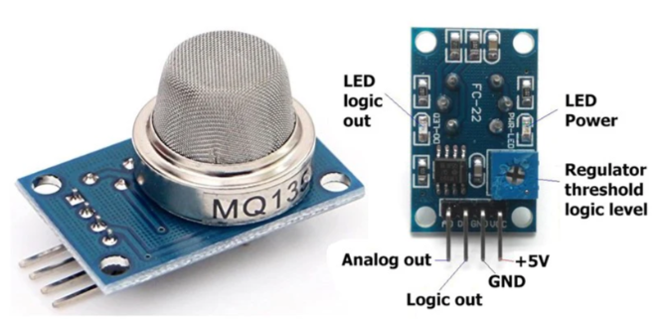

**Pin Mode:**

| MQ135 Pin | Arduino Connection |
| --- | --- |
| VCC | 5V |
| GND | GND |
| AO | A0 |
| DO | D2 (example) |

**THEORY:**

The **MQ-135 gas sensor** is used to detect harmful gases such as carbon dioxide (CO₂), ammonia (NH₃), benzene, smoke, and other air pollutants. It works based on a sensitive heating element and a semiconductor material (SnO₂), whose resistance changes when exposed to different gases.

When the concentration of gas increases, the sensor’s resistance changes, causing the output voltage to vary accordingly. The MQ-135 module provides both **analog output (AO)** for measuring the level of air quality and **digital output (DO)** for detecting when the gas concentration exceeds a preset threshold.

The sensor is widely used in **air quality monitoring systems, pollution detection projects, smart home applications, and industrial environmental monitoring systems.**

**CIRCUIT DIAGRAM:**

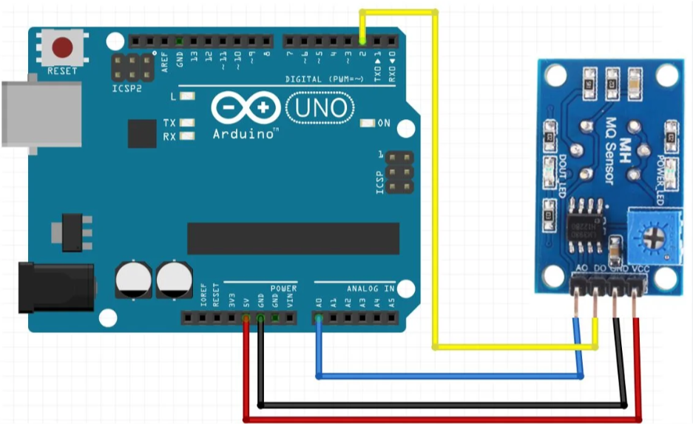

**CODE:**

int analogPin = A0; // AO connected to A0

int digitalPin = 2; // DO connected to D2

void setup() {

Serial.begin(9600);

pinMode(digitalPin, INPUT); // Required for DO

}

void loop() {

int analogValue = analogRead(analogPin); // Read analog value

int digitalValue = digitalRead(digitalPin); // Read digital value

Serial.print("Analog Value (Air Quality): ");

Serial.print(analogValue);

Serial.print(" | Digital Status: ");

if (digitalValue == HIGH) {

Serial.println("Gas Detected!");

} else {

Serial.println("Air Normal");

}

delay(1000);

}

**Experiment 4:**

**DHT11 and LCD with I2C module:**

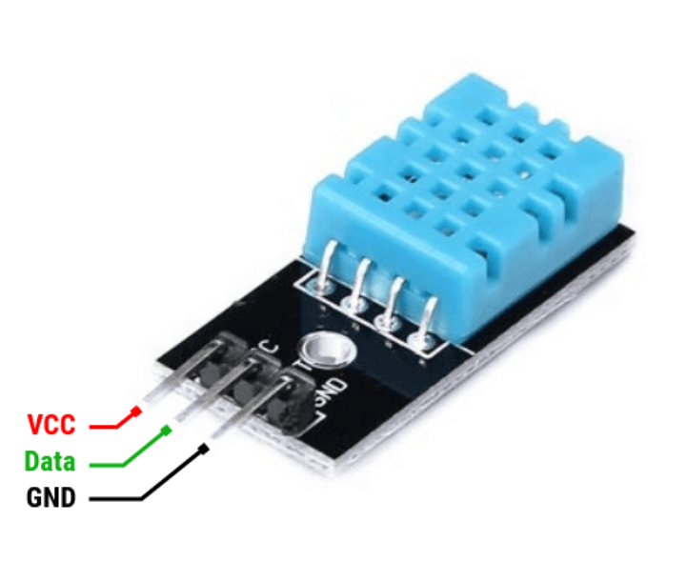

**Pin mode:**

| DHT11 Pin | Arduino Connection |
| --- | --- |
| VCC | 5V (or 3.3V) |
| GND | GND |
| DATA | D2 (example) |

**THEORY:**

The DHT11 is a digital sensor used to measure temperature and relative humidity in the surrounding environment. It is widely used in weather monitoring systems, smart homes, and IoT projects.

The sensor contains two main components:

* Humidity sensing element (capacitive type)
* NTC thermistor for temperature measurement

It also has an internal 8-bit microcontroller that converts the measured values into a digital signal and sends the data through a single data pin.

**CODE:**

#include <DHT.h>

#define DHTPIN 2 // DATA pin connected to D2

#define DHTTYPE DHT11 // Define sensor type

DHT dht(DHTPIN, DHTTYPE);

void setup() {

Serial.begin(9600);

dht.begin();

}

void loop() {

float humidity = dht.readHumidity();

float temperature = dht.readTemperature();

if (isnan(humidity) || isnan(temperature)) {

Serial.println("Failed to read from DHT sensor!");

return;

}

Serial.print("Temperature: ");

Serial.print(temperature);

Serial.print(" °C | Humidity: ");

Serial.print(humidity);

Serial.println(" %");

delay(2000); // DHT11 reading interval

}

**Theory:**

The **16x2 LCD with I2C module** is an electronic display used to show text and numerical data in Arduino and embedded projects. It works using liquid crystal technology, where electric signals control the alignment of liquid crystals to form visible characters on the screen.

The I2C module simplifies communication by reducing the number of required pins. Instead of multiple data and control pins, it uses only two lines: **SDA (data)** and **SCL (clock)**. The module converts serial data from the microcontroller into parallel signals for the LCD. It is widely used in sensor display systems, IoT projects, and smart monitoring applications.

**Pin mode:**

| **LCD I2C** | **Arduino UNO** |
| --- | --- |
| **VCC** | **5V** |
| **GND** | **GND** |
| **SDA** | **A4** |
| **SCL** | **A5** |

**CIRCUIT DIAGRAM:**

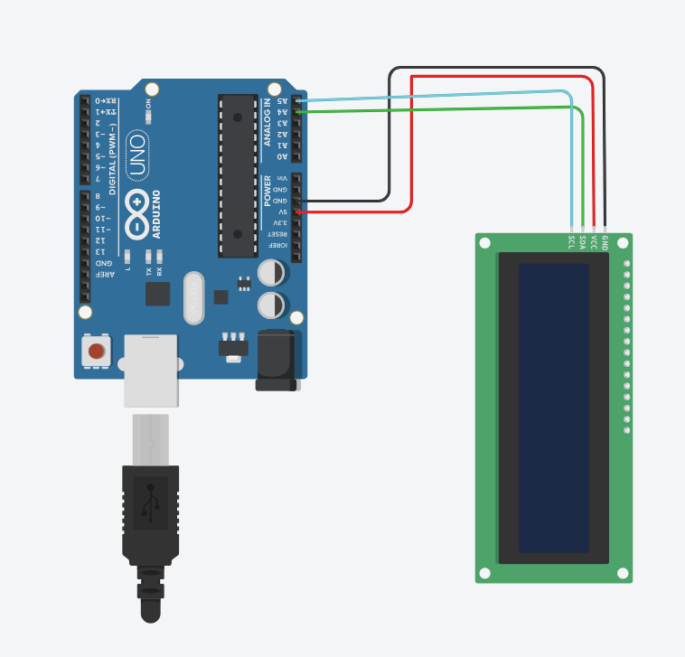

**Code:**

**Experiment 5:**

**LCD with I2Cmodule and keypad:**

**Keypad:**

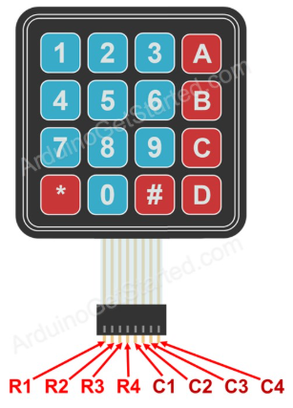

**CIRCUIT DIAGRAM:**

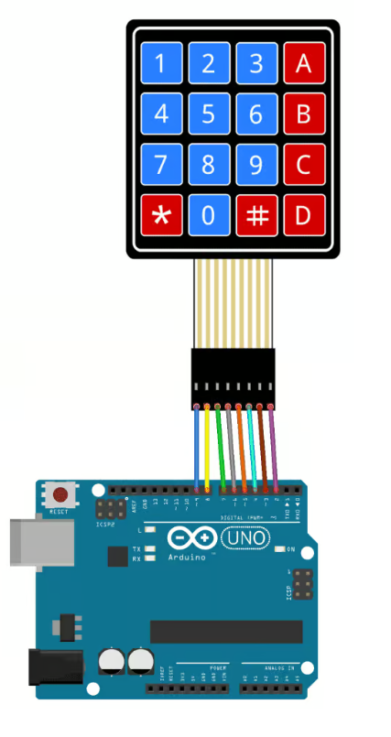

**Theory:**

The keypad is an input device used to enter numbers, characters, or commands into a microcontroller system. A commonly used keypad in Arduino projects is the 4x4 matrix keypad, which contains 16 keys arranged in 4 rows and 4 columns.

The keypad works on the principle of row and column matrix scanning. Instead of connecting each key separately, the keys are connected in a matrix format to reduce the number of required pins. When a key is pressed, it connects a specific row and column, allowing the Arduino to detect which key is pressed by scanning the rows and columns.

The Arduino sends signals to the row pins one by one and reads the column pins to check for a connection. If a connection is detected, the pressed key is identified. This method reduces wiring and saves input/output pins.

Keypads are widely used in password-based door lock systems, security systems, calculators, ATM machines, and embedded system projects where user input is required.

**Code:**

**LCD with I2Cmodule and keypad:**

**Circuit diagram:**

